Geometry: Unit 10, Lesson 4
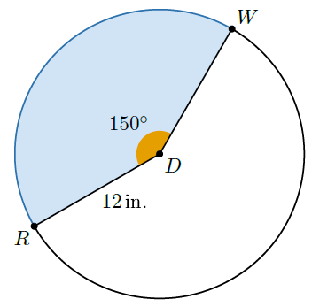
- Circle $D$ is shown with points $R$ and $W$ on the circle and a radius of $12$ inches $(in.)$, where $m∠RDW=150°$. What is the area of circle $D$?

$$144π inches^{2}$$

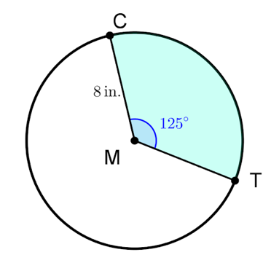
- Circle $M$ is shown with points $C$ and $T$ on the circle and a radius of $8$ inches $(in.)$, where $m∠CMT=125°$. What is the ratio of the arc length of $\hat{CT}$ to the circumference of the circle?

$$\frac{125}{360}$$

- What is a true statement about an area of a sector?

It is a fraction of the area of the circle

